Dear ___,

Welcome to our wedding weekend! We appreciate your traveling and thank you for coming to help us celebrate. It means so much to have you here. We hope you have a wonderful time and enjoy it as much
as we will.

We wanted to give you some special treats, a small thank you from us to make your stay a little more sweet. In your bag you’ll find John Deere fruit snacks (Moline is the hometown and world headquarters of John Deere), bottled water, pretzels, mints, and Kleenex (just in case you shed some tears, we probably will too!). We hope you also enjoy the cookies from our favorite bakery, Olde Towne Bakery, and the delicious chocolates from the old fashioned soda shop, Largomarcino’s.

To help you get to the wedding ceremony and reception, we have set up shuttles to take you to and from the venue and hotel. Before the ceremony, the shuttle bus will pick up at Stoney Creek’s main (parking lot side) entrance at 3pm. Then it will stop at the Isle’s main entrance at approximately 3:15pm. Shuttle vans will run at the end of the evening, 9pm-12am, to return you to your hotel.

Please be our guest for brunch on Sunday, October 17th from 9:00 to 11:00 am
at the Isle Casino Hotel Bettendorf, in the Riveria Room in Isle Center so we have a chance to see you again and say goodbye!

Love,
Hannah and Ben
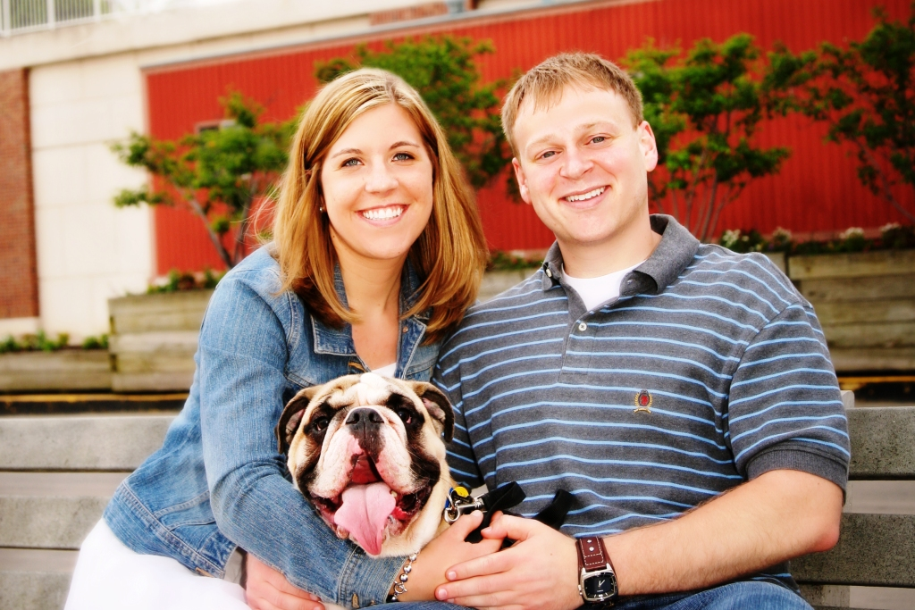

Dear ___,

Welcome to our wedding weekend! We appreciate your traveling and thank you for coming to help us celebrate. It means so much to
have you here.

We wanted to give you some special treats, a small thank you from us to make your stay a little more sweet. In your bag you’ll find John Deere fruit snacks (Moline is the hometown and world headquarters of John Deere), bottled water, pretzels, mints, and Kleenex (just in case you shed some tears, we probably will too!). We hope you also enjoy the cookies from our favorite bakery, Olde Towne Bakery, and the delicious chocolates from the old fashioned soda shop, Largomarcino’s.

We hope you have a wonderful time and enjoy it as much as we will!

Love,
Hannah and Ben

Dear ___,

Welcome to our wedding weekend! We appreciate your traveling and thank you for coming to help us celebrate. It means so much to have you here. We hope you have a wonderful time and enjoy it as much
as we will.

We wanted to give you some special treats, a small thank you from us to make your stay a little more sweet. In your bag you’ll find John Deere fruit snacks (Moline is the hometown and world headquarters of John Deere), bottled water, pretzels, mints, and Kleenex (just in case you shed some tears, we probably will too!). We hope you also enjoy the cookies from our favorite bakery, Olde Towne Bakery, and the delicious chocolates from the old fashioned soda shop, Largomarcino’s.

To help you get to the wedding ceremony and reception, we have set up shuttles to take you to and from the venue and hotel. Before the ceremony, the shuttle bus will pick up at Stoney Creek’s main (parking lot side) entrance at 3pm. Then it will stop at the Isle’s main entrance at approximately 3:15pm. Shuttle vans will run at the end of the evening, 9pm-12am, to return you to your hotel.

Love,
Hannah and Ben

